EC-467 Mobile Application Development

BS (CE)-2021 LAB REPORT #12
Submitted By:

Reg. No. | Name
21-CE-009 | Huzaifa Shahbaz

Department of Computer Engineering
HITEC University Taxila
 | Presentation  (Format(0.5)+  Title (0.5)+  Conclusion(1)  +Procedure(2)  +Objective(1)) | Calculation/ Coding | Observation/  Program Results | Total
Total | 5 | 5 | 5 | 15
Obtained

Lab Instructor.
Dr. Muhammad Bilal

LAB REPORT #12
Android Networking using Volley Library
Introduction: Volley is an HTTP library that makes networking for Android apps easier and most importantly, faster Volley offers the following benefits: i.Automatic scheduling of network requests ii.Multiple concurrent network connections iii.Transparent disk and memory response caching with standard HTTP cache coherence iv. Cancellation request API. You can cancel a single request, or you can set blocks or scopes of requests to cancel. v. Strong ordering that makes it easy to correctly populate your UI with data fetched asynchronously from the network.
Objectives of the experiment: i.To get basic understanding regarding android volley networking. ii.To get basic understanding regarding how to use volley networking in HTTP connections. iii. To get to know about the benefits related to android volley networking.
Tools: Android Studio Jellyfish
Class Task JAVA CODE OF Main Activity: package com.huzaifashahbaz.volleyapp;
import androidx.appcompat.app.AppCompatActivity;
import android.os.Bundle;
import android.util.Log;
import android.widget.TextView;
import com.android.volley.Request;
import com.android.volley.RequestQueue;
import com.android.volley.Response;
import com.android.volley.VolleyError;
import com.android.volley.toolbox.StringRequest;
import com.android.volley.toolbox.Volley;
public class MainVolleyNetwork extends AppCompatActivity {
@Override
protected void onCreate(Bundle savedInstanceState) {
super.onCreate(savedInstanceState);
setContentView(R.layout.activity_main);
TextView tv = findViewById(R.id.response_tv);
// Instantiate the RequestQueue.
RequestQueue queue = Volley.newRequestQueue(this);
String url ="https://www.york.ac.uk/teaching/cws/wws/webpage1.html";
StringRequest stringRequest = new StringRequest(Request.Method.GET, url,
new Response.Listener<String>() {
@Override
public void onResponse(String response) {
Log.d("Main", "Response is" + response);
tv.setText(response);
}
},
new Response.ErrorListener() {
@Override
public void onErrorResponse(VolleyError error) {
Log.d("Main", "No response");
}
}
);
queue.add(stringRequest);
}
}
XML CODE OF Main Activity: <?xml version="1.0" encoding="utf-8"?>
<LinearLayout xmlns:tools="http://schemas.android.com/tools"
xmlns:android="http://schemas.android.com/apk/res/android"
xmlns:app="http://schemas.android.com/apk/res-auto"
android:layout_width="match_parent"
android:layout_height="match_parent"
android:orientation="vertical">
<TextView
android:id="@+id/response_tv"
android:layout_width="match_parent"
android:layout_height="wrap_content"
android:text="HTML"/>
</LinearLayout>
Results:
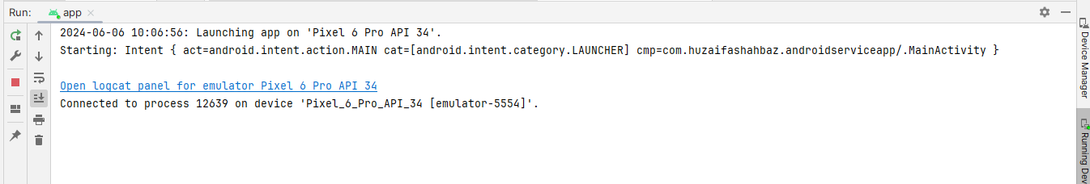
OUTPUT: 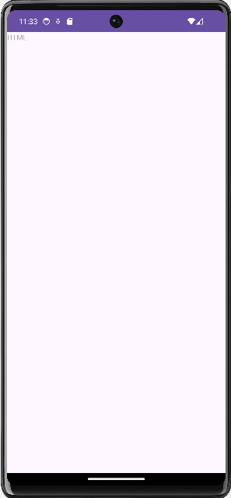
Conclusion: In conclusion, I know how to make Android Networking using Volley Library by using java and xml(linear layout)code and also we make the website through the internet and also by java and linear layout.

